**Project Name:** Lostine River/City of Lostine Diversion Structure Replacement

**Applicant:**

Grande Ronde Model Watershed

1114 J. Ave.

La Grande, OR 97850

Email: [Coby@grmw.org](mailto:Coby@grmw.org)

Phone: 541.663.0570

Fax: 541.962.1585

**Participating Landowner(s) and Agencies:**

|  |  |  |  |  |  |
| --- | --- | --- | --- | --- | --- |
| Participant | Contact | Role | Address | Phone | Email |
| GRMW | Coby Menton | Project Manager | 1114 J Ave.  La Grande, OR 97850 | 541.663.0570 | coby@grmw.org |
| ODFW | Jeff Yanke | Land owner representative | 65495 Alder Slope Road  Enterprise, OR 97828 | 541.426.3279 | Jeff.Yanke@state.or.us |
| Anderson Perry | Chas Hutchins | Design & Engineering | PO Box 1107  La Grande, OR  97850 | 541.963.8309 | bmoore@andersonperry.com |
| ODFW | Bill Knox | Technical support | 65495 Alder Slope Road  Enterprise, OR 97828 | 541.426.3279 | Bill.Knox@state.or.us |

**Project Contact(s):**

|  |  |  |  |  |
| --- | --- | --- | --- | --- |
| Contact | Role | Address | Phone | Email |
| Coby Menton | Technical | 1114 J Ave.  La Grande, Or. 97850 | 541.663.0570 | coby@grmw.org |
| Mary Estes | Administrative | 1114 J Ave.  La Grande, Or. 97850 | 541.663.0570 | mary@grmw.org |

**Project Location:**

* Legal Description: Township 1 South, Range 43 East, SE ¼ of NW ¼ Section 22.
* Latitude: 45.468496.

Longitude: -117.424754.

**Project Objectives:**

1. Improve year round passage for all life stages of aquatic organisms.
2. Reduce sedimentation from periodic structure maintenance activities.
3. Promote natural bedload transport through this stream channel.

The Grande Ronde Subbasin Plan Supplement identifies the importance of this project in the following sections:

1. 5.2.2.1, page 37, GRSBP. Provide connectivity between functioning habitats.
2. 5.2.4.1, page 38, GRSBP. Protect high quality habitat and protect and restore connectivity of functioning habitats.
3. Table 5.4, Wallowa – Lostine River, page 40, GRSBP. Priority attribute sediment (reduction)
4. Table 5.6, page 50, GRSBP. Grande Ronde Subbasin watersheds listed in order of potential impact to steelhead and spring Chinook populations (abundance and productivity) from comprehensive habitat restoration: Wallowa – Lostine is the highest ranked watershed.

**Project Description:**

Introduction

With the cooperation of the Lostine Ditch Company, technical assistance from ODFW, and engineering services of Anderson Perry (AP) the GRMW will complete this diversion structure replacement project during the instream work window in the summer of 2012. AP has accomplished survey and design and will acquire removal/fill permits. The GRMW will accomplish all other environmental compliance requirements. The GRMW is the project sponsor and responsible for all contracting and AP will supply construction engineering. The resulting project will be a diversion structure that requires minimal annual instream maintenance, results in reduced erosion and sedimentation, and improves aquatic passage conditions.

Existing Condition

The existing diversion structure was built in the early 1960’s, is aging, has been repaired in the past and restricts passage of juvenile anadromous and resident fish at some flows. Past repairs have included shoring the channel spanning concrete walls with rock to prevent potential failure and piling debris below the structure to improve passage conditions. These efforts have improved structural integrity and passage conditions but were intended as temporary fixes until a new facility can be constructed. This aging structure does not meet State and Federal fish passage criteria as currently applied.

Currently the Lostine Ditch Diversion is used during the Wallowa Valley irrigation season, which starts on May 1st and ends on September 30th. At all times of the year this ditch delivers stock water at a much lower rate than during irrigation season. A fish screen composed of three paddle wheel operated drums is located near the diversion. Adjacent to the diversion is a concrete step-pool type structure composed of five steps. The steps span the width of the river and each has two to three notches approximately 3 feet wide. The elevation difference between each step is approximately 15 inches, which exceed fish passage criteria. Downstream of the steps is large riprap and debris such as concrete pieces, wood, etc., that provide scour control.

The project site will be constrained by two existing structures. A private bridge located approximately 400 feet downstream of the diversion head gate precludes altering the river on the downstream end of the project site. The upstream wall of the fish ladder serves as the existing irrigation diversion structure and constrains the project on the upstream end. The irrigators served by the ditch have requested not to modify the most upstream step of the diversion structure. The designs as presented in this proposal do not call for a modification of the most upstream step.

Fish that are native to the Lostine River include spring Chinook, summer steelhead, rainbow trout, and bull trout as well as other resident species. Design criteria to pass spring Chinook, bull trout, and steelhead are the most stringent and have been used for design purposes.

Spring Chinook migrate through the Lostine system to their spawning areas between mid-June and mid-September. Summer steelhead migrate to their spawning areas in late winter and spring. Bull trout utilize the project site as a migratory corridor between upstream spawning areas and downstream rearing and foraging areas, typically migrating upstream in late spring and early summer and downstream in late fall. Temperature and turbidity are two environmental factors that can affect migration patterns of fish. As temperatures start to rise, fish tend to move upstream into cooler waters. Turbidity, especially when coupled with high flows, may temporarily inhibit fish movements.

**Specific Actions**

1. Coordination – Initial coordination is complete between the GRMW and ODFW. GRMW is the project sponsor, ODFW owns the facility and is providing technical assistance. The Lostine Ditch Company will be consulted prior to construction to ensure irrigation water is delivered during construction.
2. Design & Engineering – GRMW contracted AP to complete initial design concept and final engineering complete with construction specifications. The deliverable is final design with construction specification and will be complete in the fall of 2011.
3. Environmental compliance –ESA Section 7 Consultation will be completed with USFWS through the Partners for Wildlife Programmatic process that covers consultation for both USFWS and NMFS. GRMW will contract with AP to complete removal/fill permit applications. The first deliverable is biological clearance for the project as stated in the letter of concurrence from USFWS complete with terms and conditions of project construction. The second deliverable is removal/fill permits from both Oregon DSL and Army Corps’ of Engineers complete with terms and conditions of project construction. Cultural resources consultation will be initiated in the fall of 2011. This specific action will be complete by March 15th, 2012.
4. Contracting – GRMW will contract with BPA and ODFW for funds to implement the project. GRMW will also advertise for and retain a construction contractor and materials provider to build the project. All contracts will be in place by June 15th, 2012.
5. Construction – The project will be constructed during the in-stream work window for this reach of the Lostine River during the summer of 2012. Anticipated work includes mobilization, delivery of rock & large wood material, installation of the roughened channel, site clean-up and final grading, planting and demobilization. The recommended instream work window is between July 15th and August 15th. The in-water construction phase of this project is expected to last no longer than the instream work window. The project will be complete by November 15, 2012. Construction elements include the following (see design sheets attached):
   1. Cross Vanes – Construction of the roughened channel over the 325 foot project length includes installation of 10 cross vanes. These vanes are built using 36 to 48-inch boulders, are keyed into each streambank and angle upstream. The primary purpose of the cross vanes is to maintain grade and stabilize the channel.
   2. Boulder Clusters – In the project reach and between the cross vanes boulder clusters will be installed. These features are each built with three 36 to 48-inch rocks, placed in groups near the surface and buried 60% to achieve hydraulic roughness and resting locations for fish.
   3. Low Flow Channel - A low flow channel will be constructed to concentrate flow and provide passage during low flow times of the year. The low flow channel is implemented by building notches in the cross vanes.
   4. Pools - Two pools will be constructed, one at the bottom and another approximately midway through the project. The two pools will provide resting areas for fish as they pass through the project area.
   5. Stream Simulation Material – This material is a mix of fine to course rock that will be used to meet grade through the project reach. The fine material will fill the interstitial space between the course rocks and prevent flow from going subsurface in the project area.
   6. Woody Material – Three woody debris features will be installed. These features provide some bank stability and enhance fish habitat value in the area. The woody debris structures are built using three rootwads with a length of 20 feet and a diameter of no less than 18 inches 10 feet from the root wad. The logs are woven together, pinned, keyed into the bank 15 feet, and held in place with large boulders.
   7. Planting – All disturbed area will be restored with native grass seed material. Native live stakes will be planted along the streambank using an excavator-mounted stinger. The bottom of each live stake will be planted into the saturation zone enhancing survival rates. Planting will occur in the fall during the dormant season and prior to the ground freezing.

**Benefits**

When complete this project will have addressed a multitude of instream parameters of concern in the Lostine River at the project site. Aquatic passage is the primary concern especially in the summer months when the Lostine can experience warm stream temperatures. Habitat conditions upstream are variable but cool water is characteristic further upstream. While uncommon, the current diversion does need to be fixed periodically which disturbs the channel and causes sedimentation. The new structure will be more stable and maintenance activities will be eliminated or reduced. Advantages of the chosen design alternative include:

1. Provide a more natural channel than what currently exists.
2. Improved fish passage.
3. Low diversion structure maintenance.

Velocity design criteria as published by National Marine Fisheries Service (NMFS) and Oregon Department of Fish and Wildlife (ODFW) will not be met due to project constraints (see existing condition above) and the natural gradient of the River.  It was determined by ODFW and NMFS that fish passage would be improved by implementing the option presented in this proposal.  This option was designed based on a design methodology in the California Salmonid Stream Habitat Restoration Manual which is commonly used in that State and is commonly referenced by NMFS engineers.  At this time US Fish and Wildlife Service has reviewed the design as presented. While they are not fully committed to approving the design it is anticipated that if changes are suggested they will be minor and have little to no effect on the budget. We expect to receive comment from them in early December. Based on this we believe that fish passage will be improved and a barrier to fish will have been eliminated in the Lostine River except during those times of highest flow and resultant high velocities.

Due to the turbulent nature (various changes between subcritical and supercritical flow) of flow during flood conditions in this reach there is not a good way to predict precise water surface elevations at any given point.  The average overall slope of the reach would remain unaltered due to the fact that we are tying into the existing streambed up and downstream of the project reach.  It is anticipated that the water surface elevations would be generally increased in the vicinity of where we would be raising the streambed.  That being said, we also anticipate that the increase in water surface elevation through the reach would not be significant given the improvements. We are confident that the increased water surface elevation that will occur during flood conditions will be contained in the channel. Both stream banks through the project reach are high, heavily armored and stable. If floodwater were to escape it would occupy a side channel on the west side and course back to the river downstream.

**Project Maintenance**

As demonstrated by several cross-vane diversion structures constructed with large rock and/or wood in Wallowa County very little if any maintenance is required while maintaining aquatic passage. Examples include the Tully-Hill diversion on the Lostine River, the Chamberlain diversion in Bear Creek and the Lower Valley diversion on the Wallowa River. If maintenance becomes necessary the GRMW will consult with ODFW and AP to determine appropriate actions.

**Permits**

As discussed in specific actions, bullet #3, environmental compliance will be completed cooperatively by the GRMW and AP by March 15th, 2012.

**Monitoring Plan**

1. Project completion report 60 days following project completion. Report will follow GRMW/BPA report guidelines.
2. Monitoring report at years 1, 3, & 5 following project completion. These reports will focus on project objectives and document structure stability, erosion, sedimentation and aquatic passage. Cross-sections and a longitudinal profile will be installed to measure lateral and vertical change following construction.
3. Photo points will be installed at each cross section and photos will be taken both upstream and downstream on an annual basis for the 5 year monitoring duration. Photos will also be taken pre, post and during construction.

**Work Dates**

The recommended instream work window for this project will be from July 15th through August 15th. Initial construction including mobilization and materials staging could start as early as June 1, 2012 and all instream work will be complete prior to August 15th, 2012. Site cleanup and demobilization will be complete by September 15th, 2012. Restoration planting including seeding, shrub and tree planting will occur in November of 2012.

We are requesting the BPA contract begin on January 1, 2012 and end December 31, 2012

**Project Budget:**

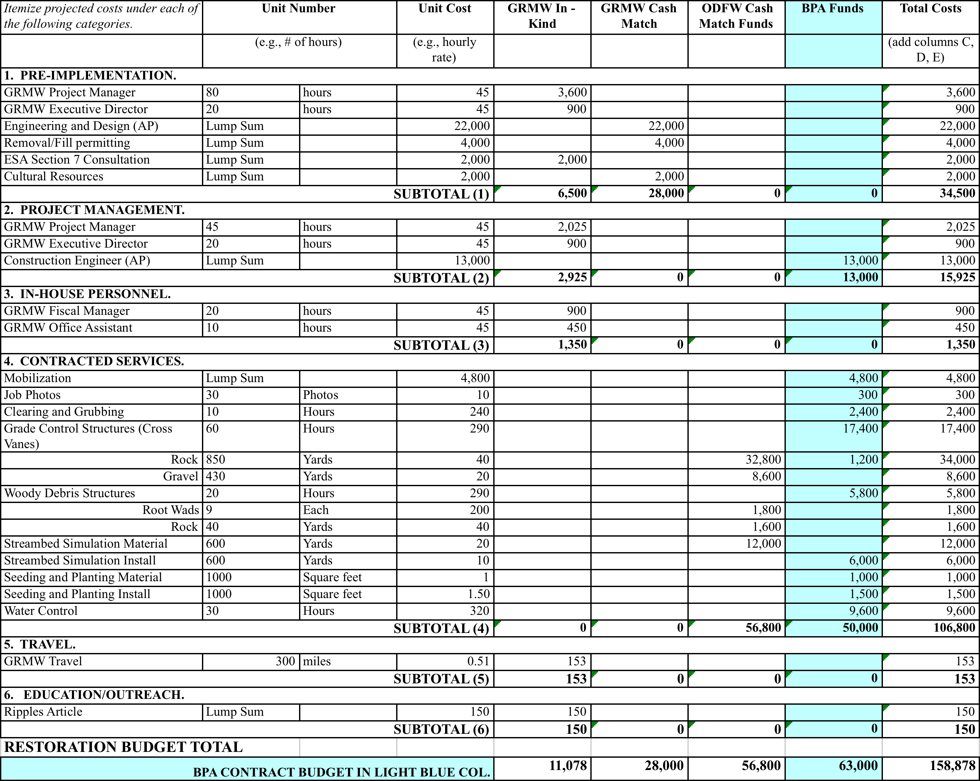

**Design Sheets:**

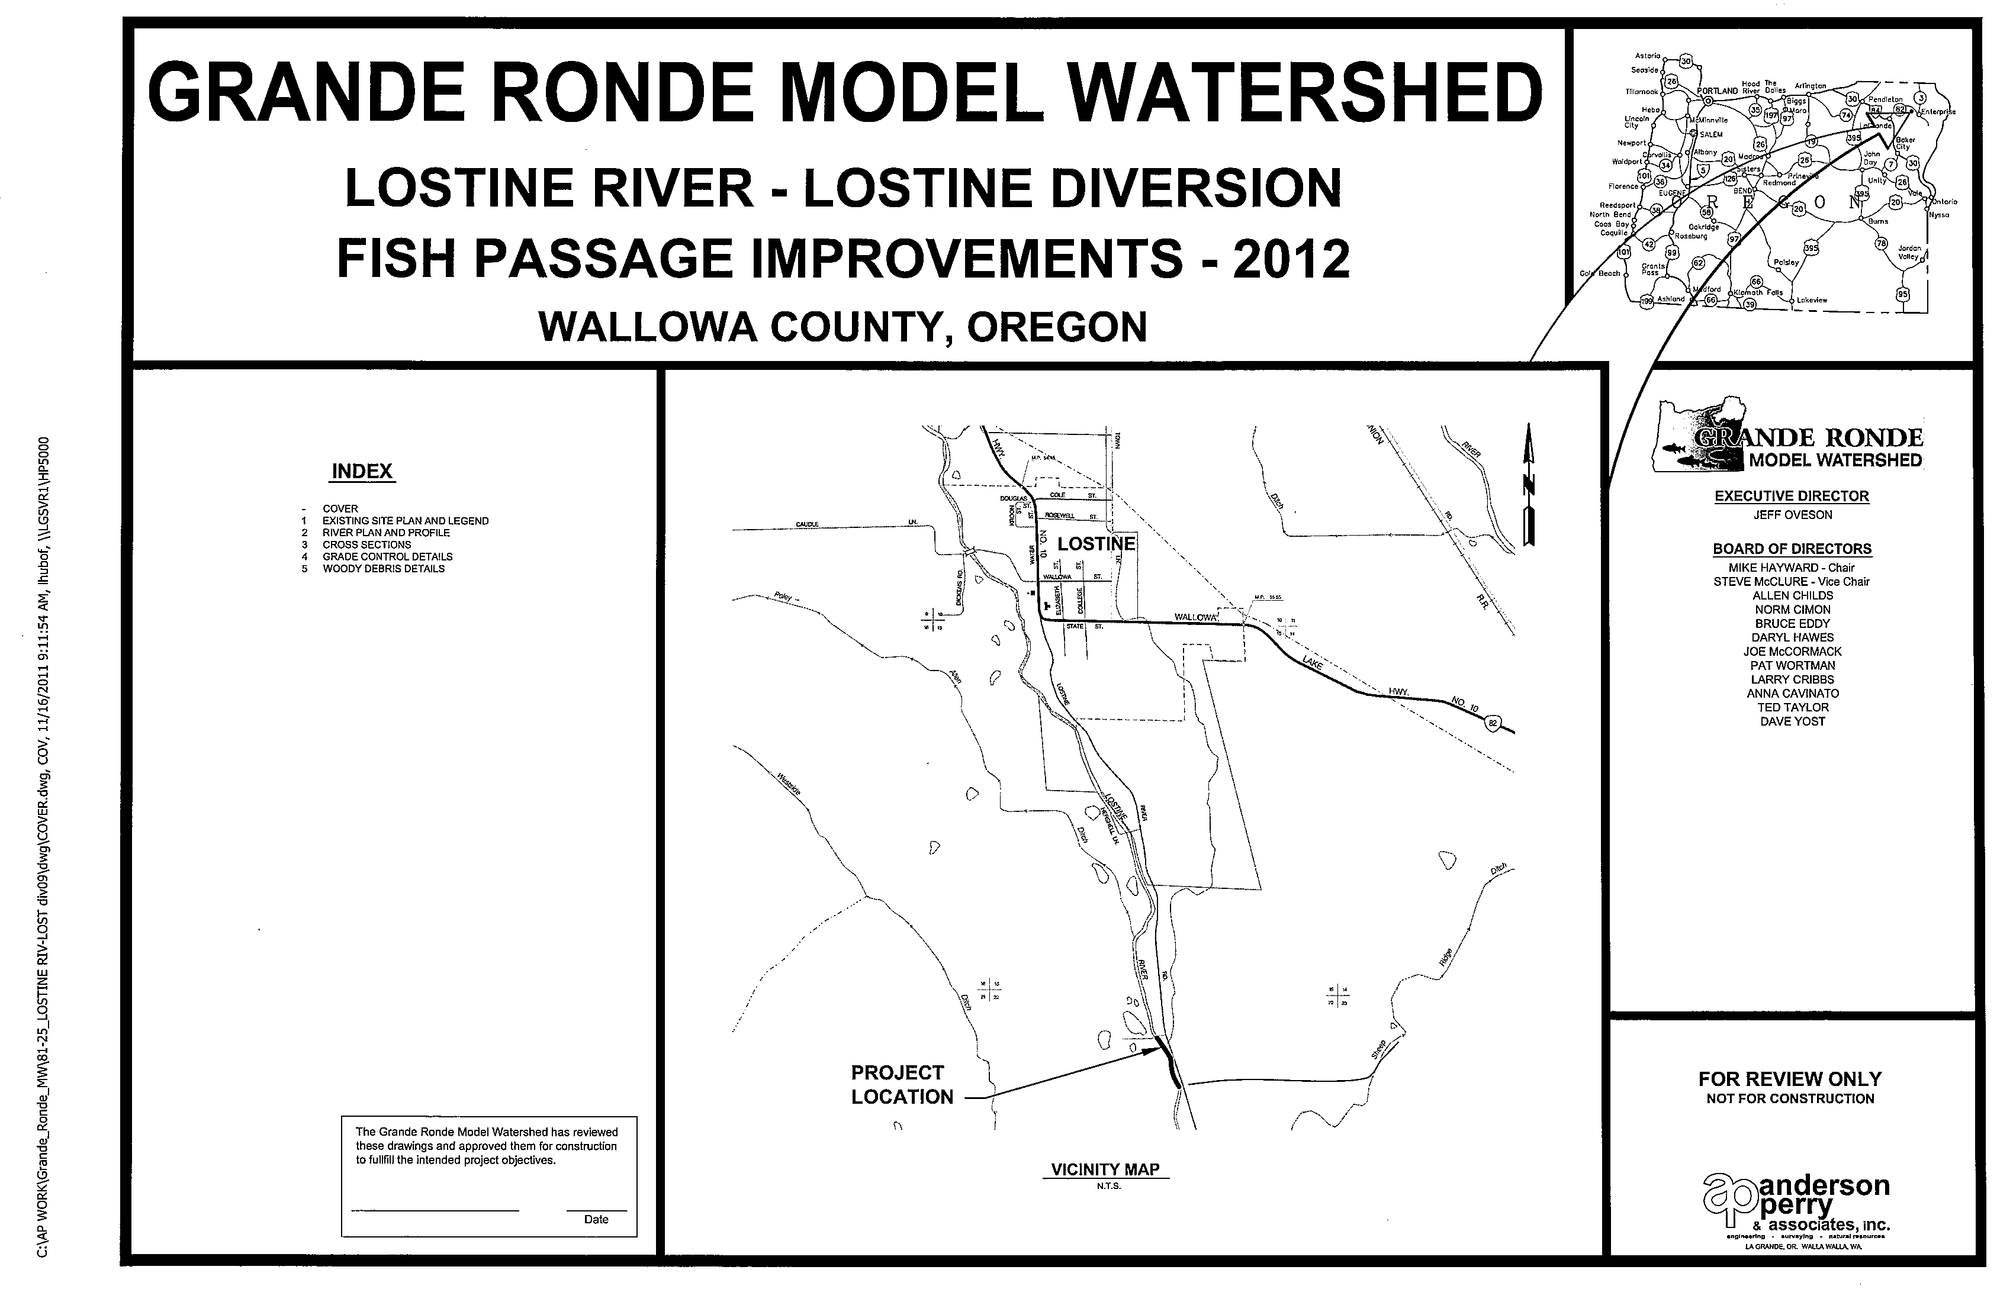

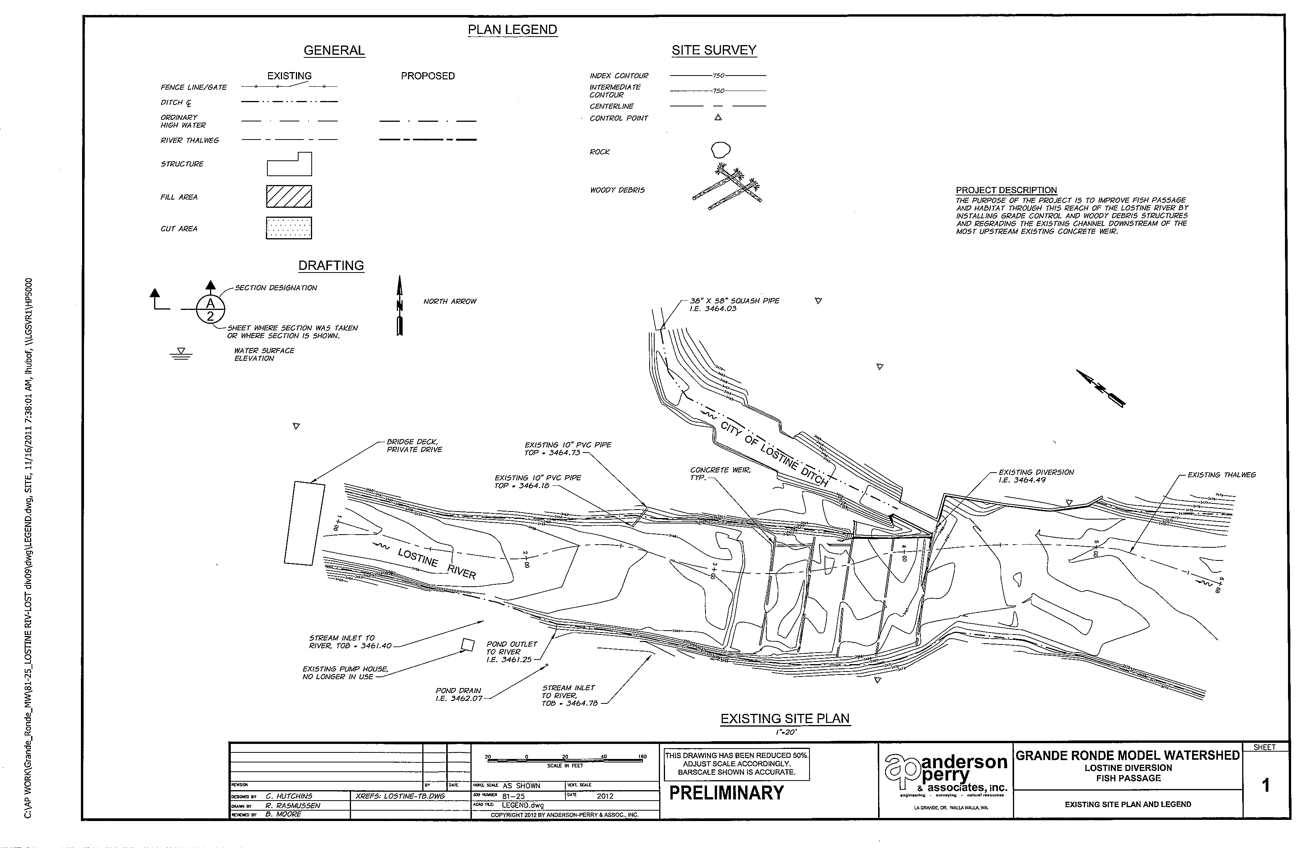

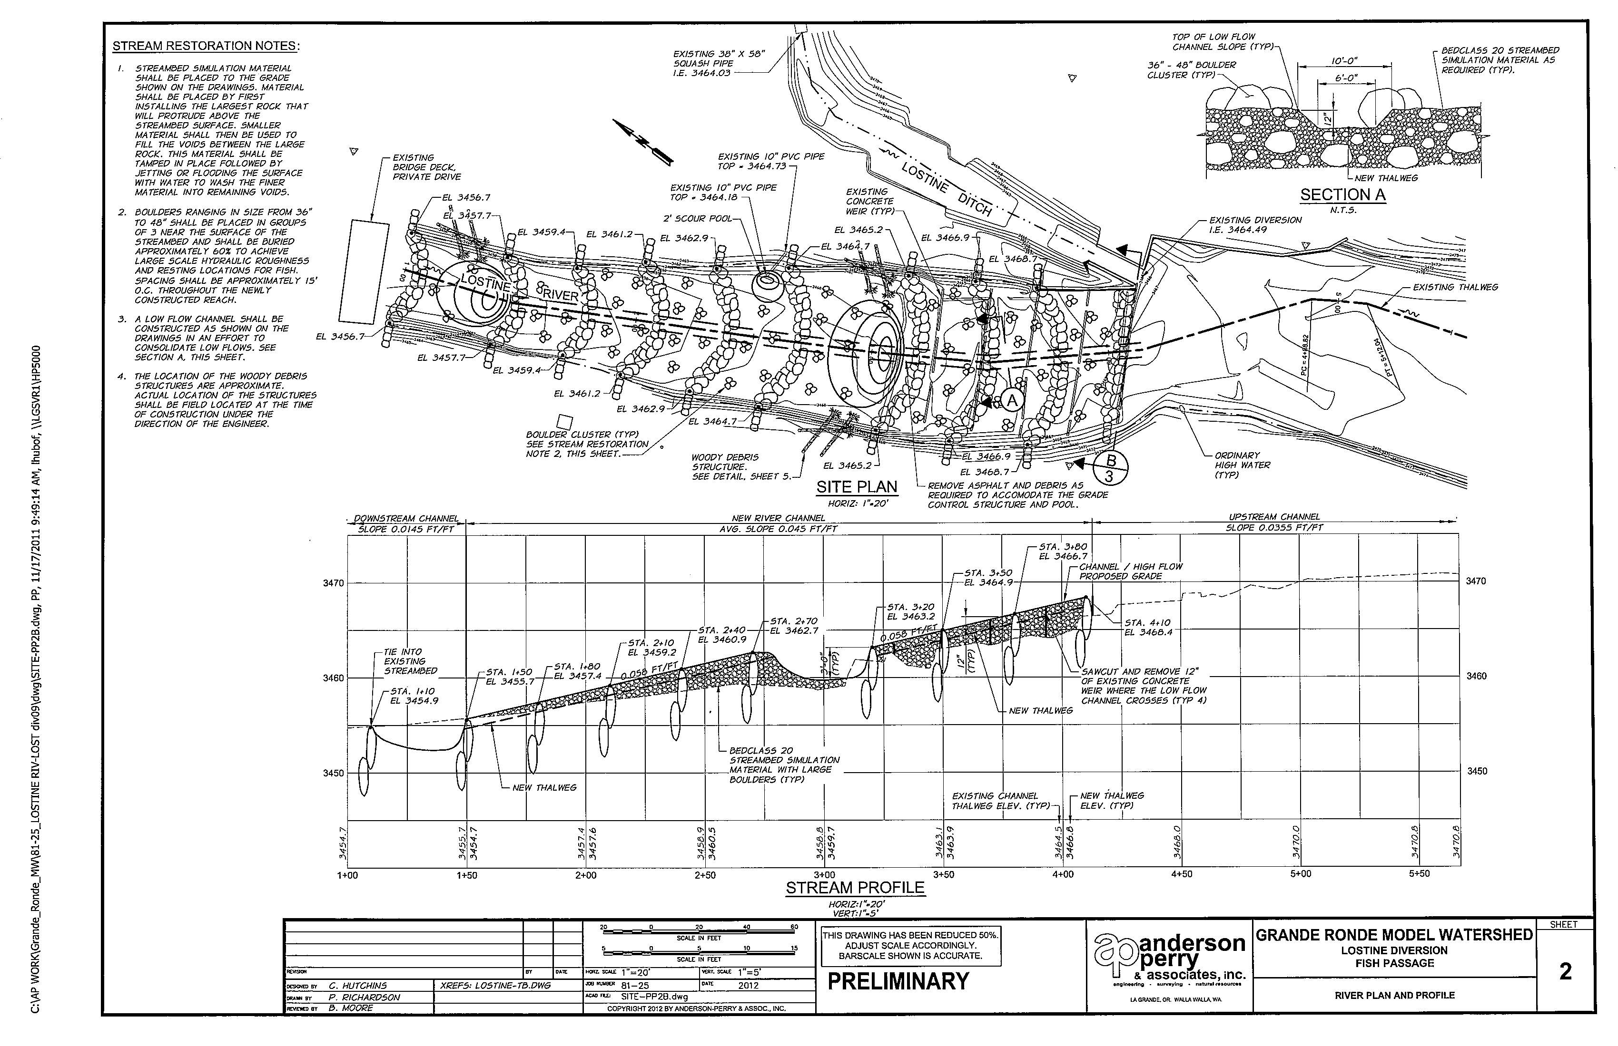

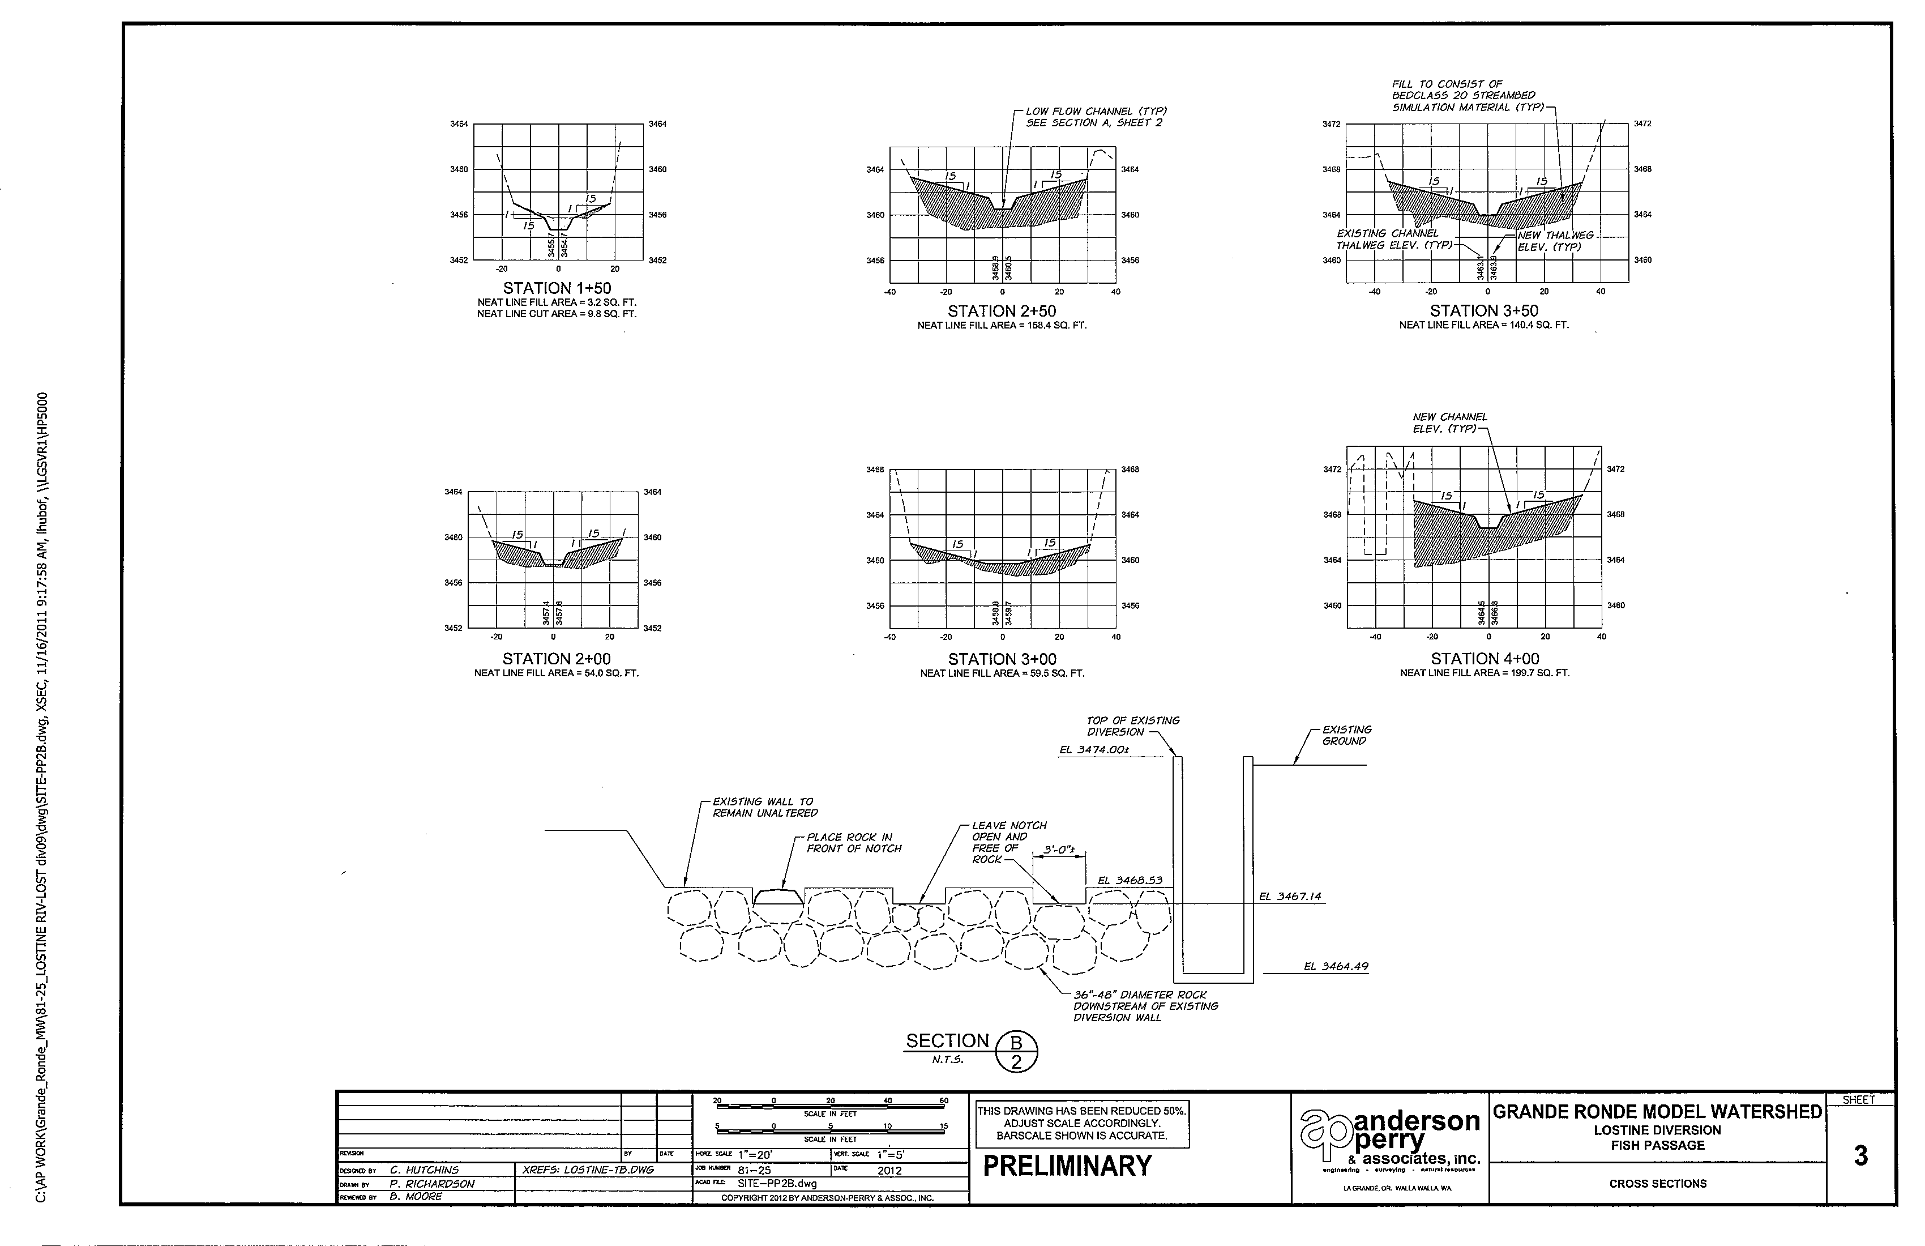

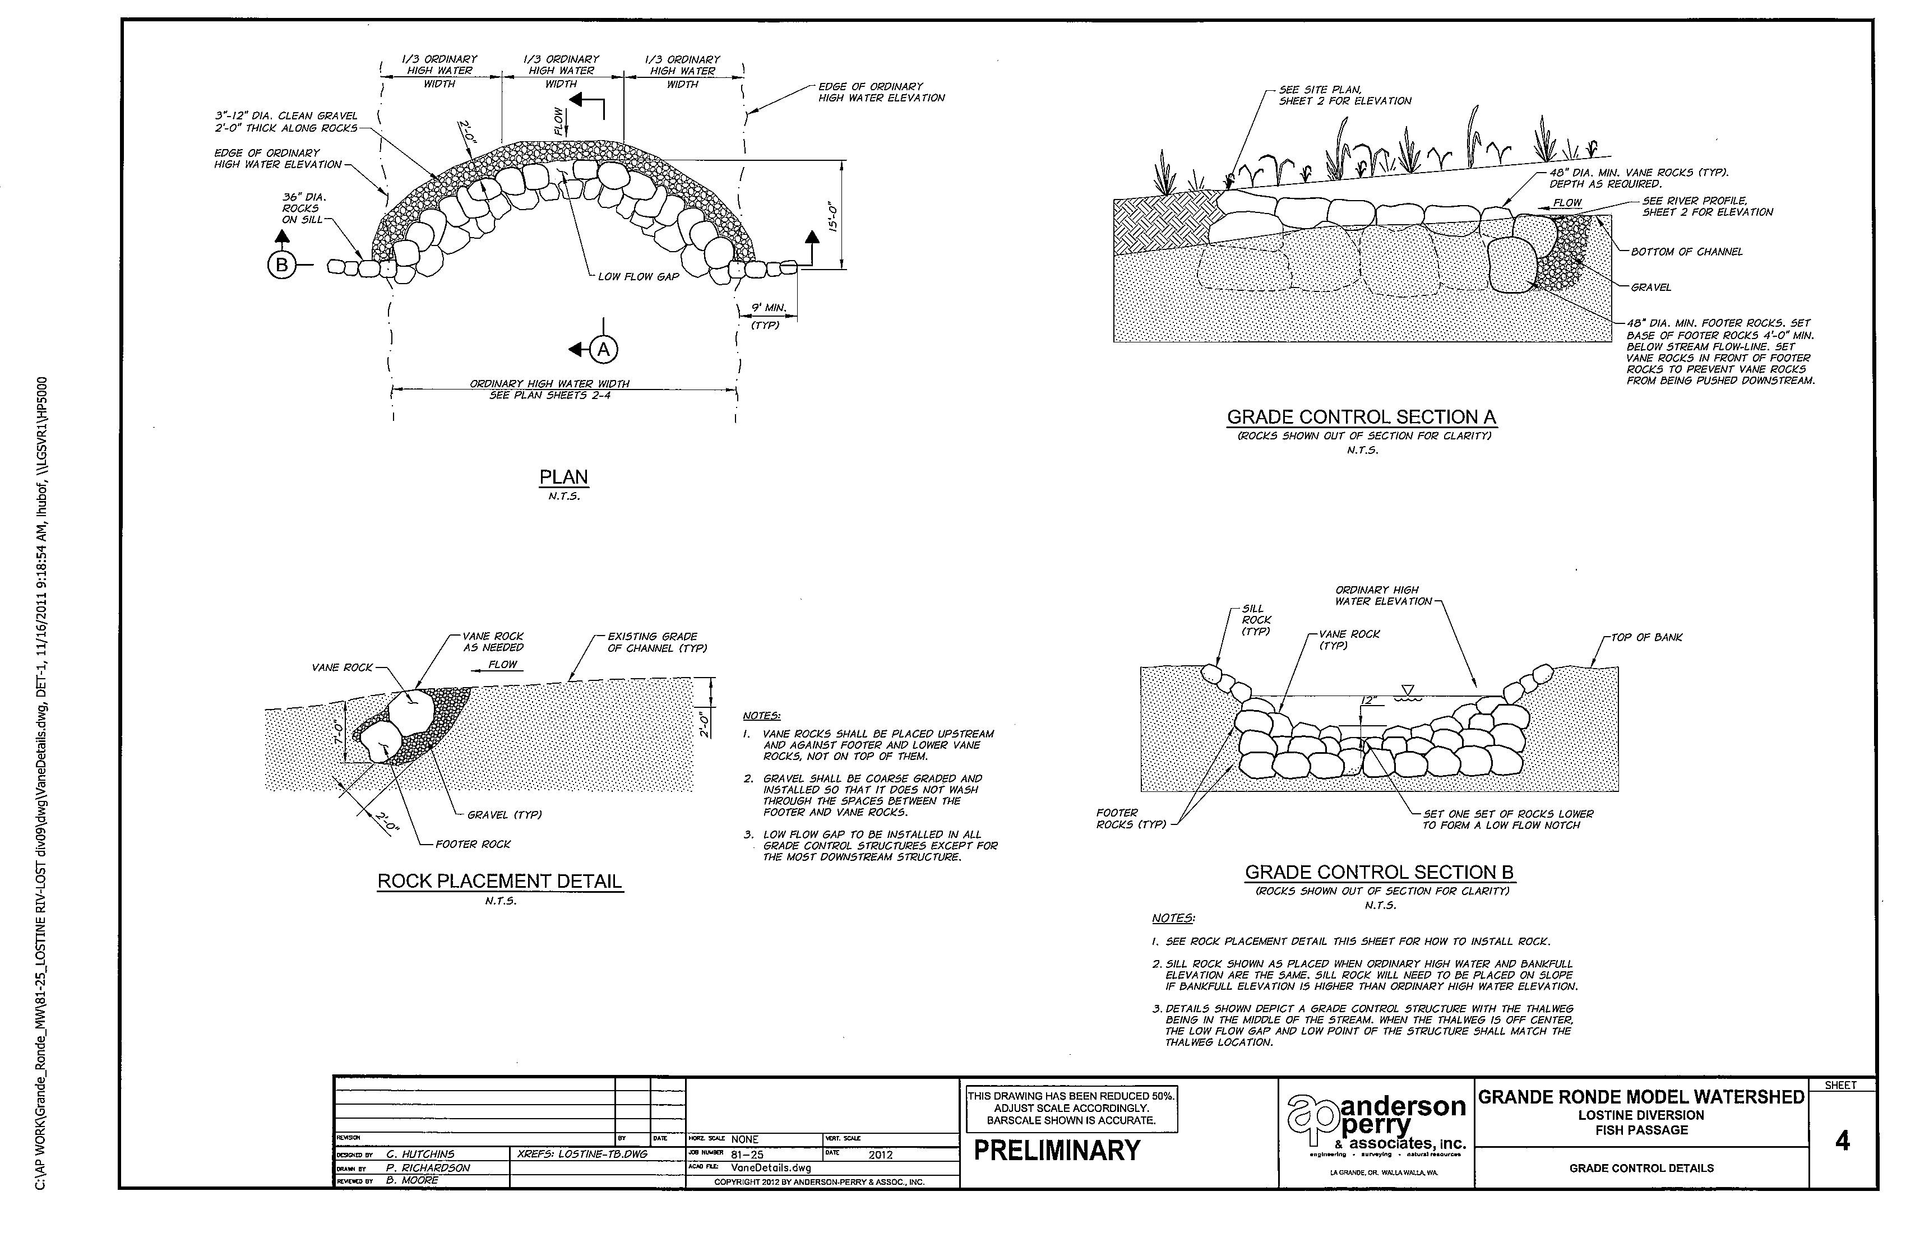

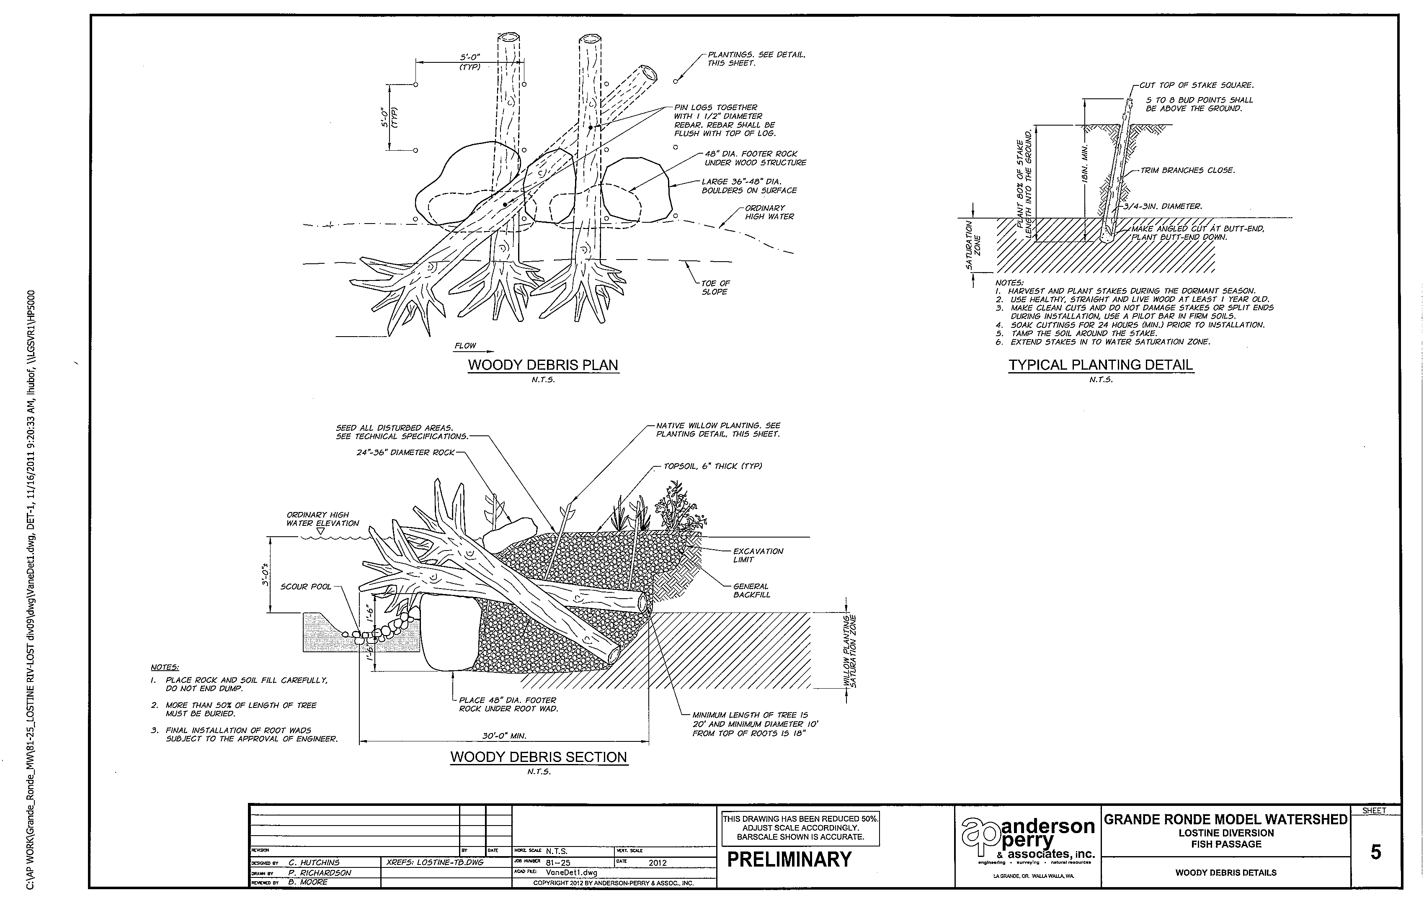

**Photos:**

